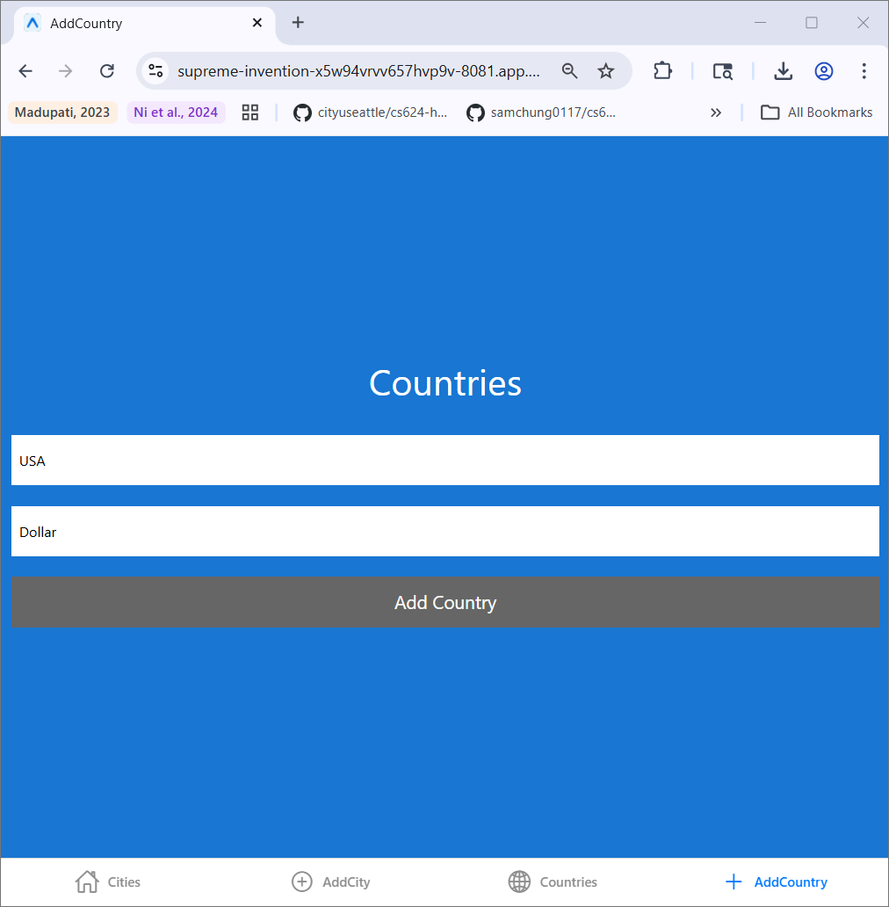
CS624 Full-Stack Development Mobile App
PE06 – Cities with Countries and Currency using Tab and Stack-based Navigations
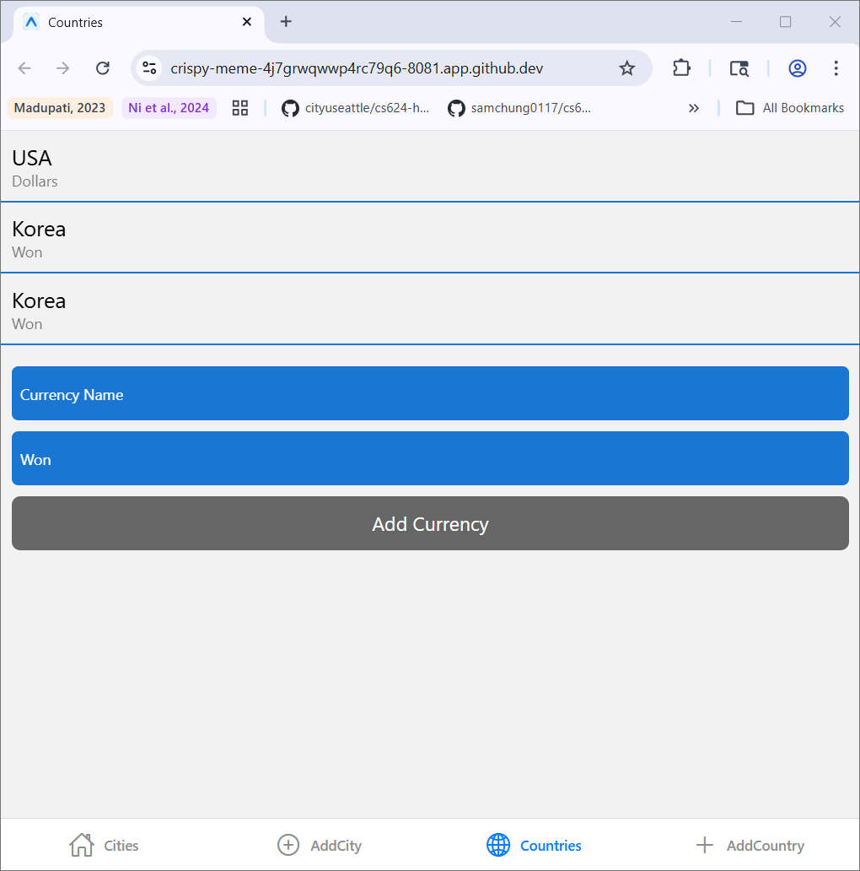
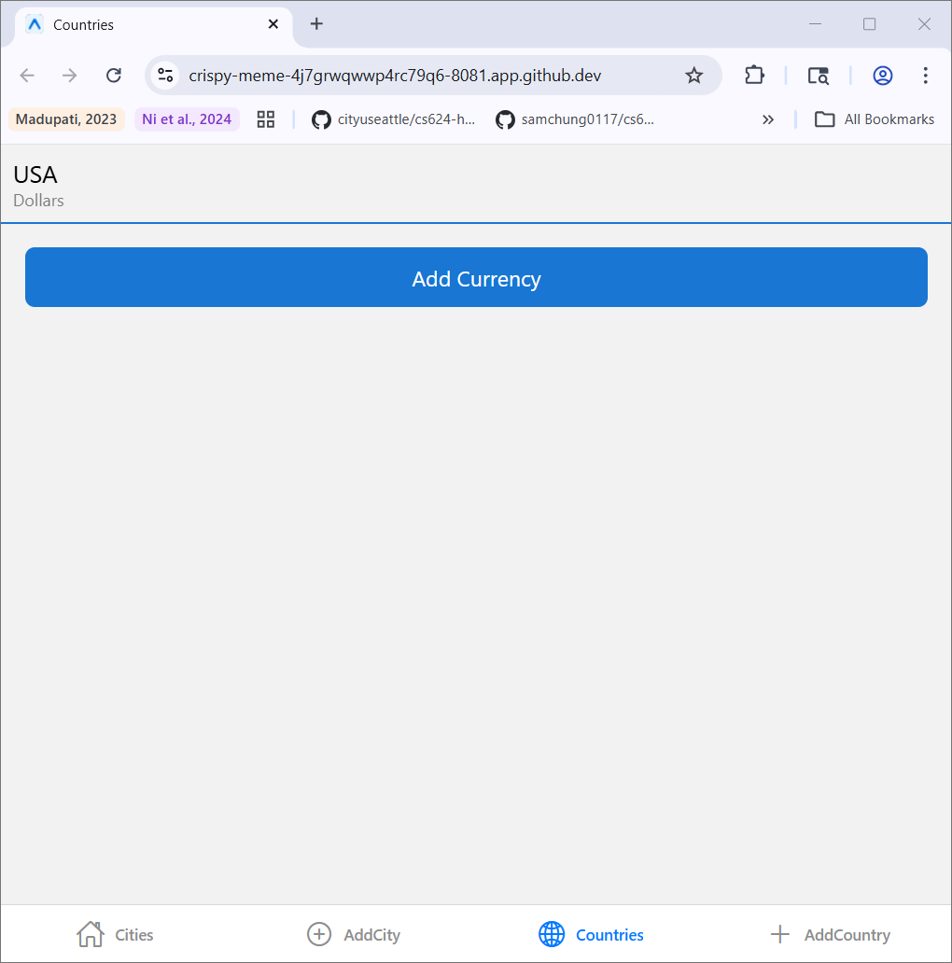
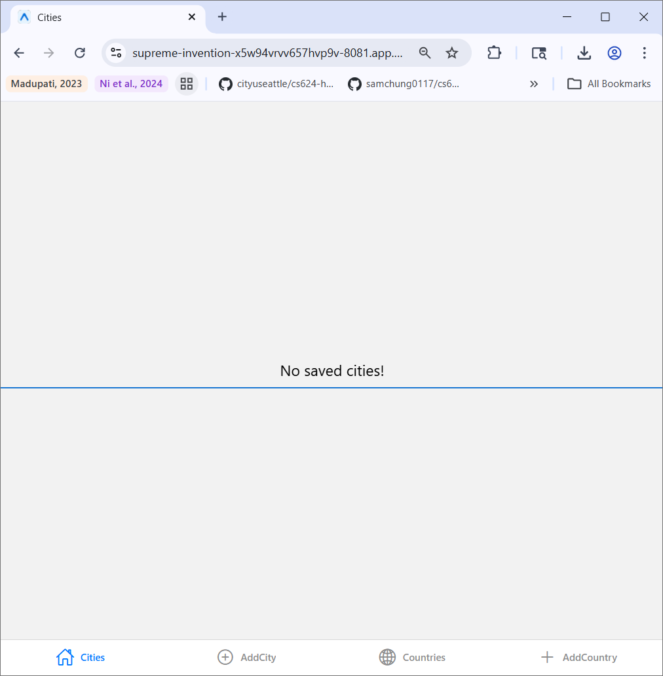

Summary:
The Countries tab in the CitiesApp manages currency data. User enters a currency name in the field along with country name. the button Add Country function validates the input and creates a new entry and appends it to the countries array. The user can navigate between screens. This application ensures user data is captured and displays in real time.
Submission
- “PE06-CitiesWithCountriesCurrencyStackNav.”
- Finish your programming exercise under the PE06 directory.
- Write a 150-word analysis report to explain how the program works in README.md regarding the input-process-output model. The README.md has three level-1 headings – Input, Process, and Output.
- Submit the link of your GitHub repository to your course shell through your assignment submission.

